SOFTWARE

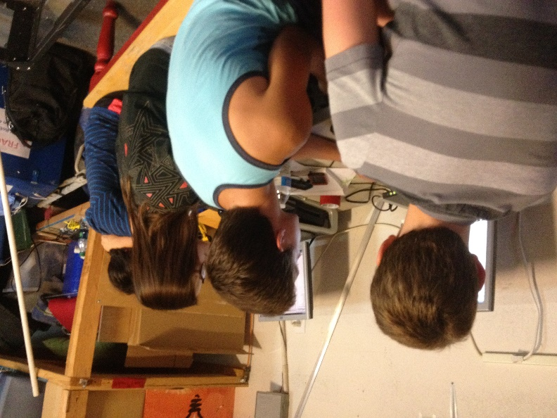
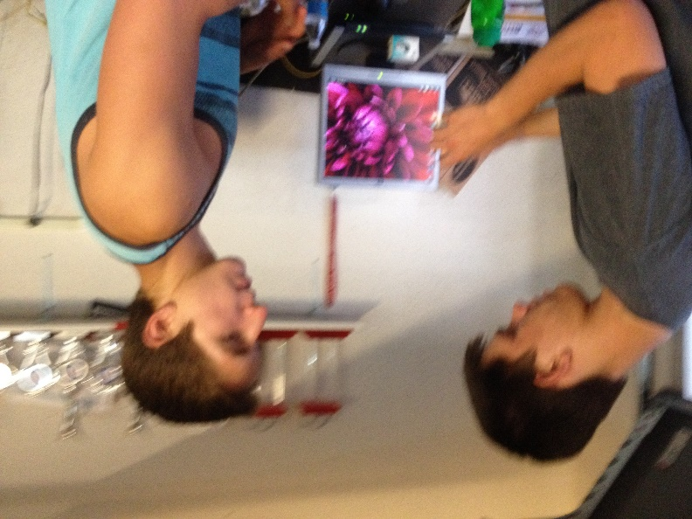
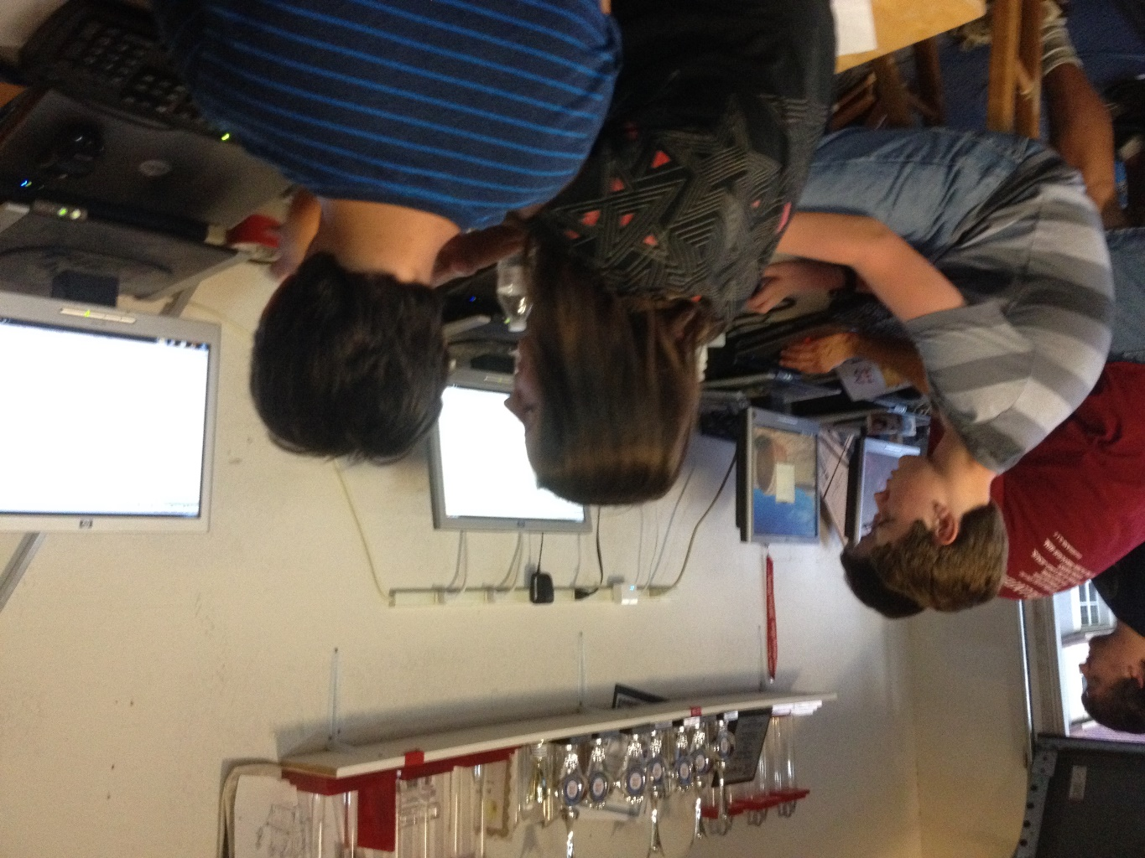
TELE-OP
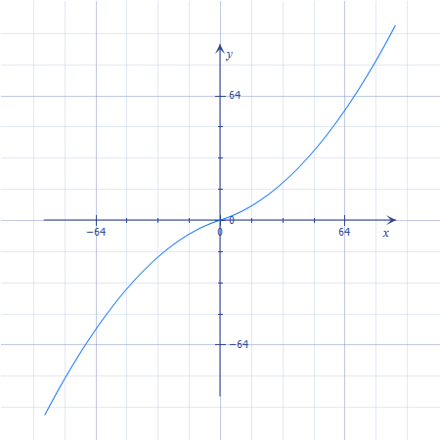
One thing that our team is very proud of with our tele-ops is our use of stick-shaping. Stick shaping is when you don't just apply the direct joystick value to the power or speed of the motor. The power or speed is determined by “shaping” the value of the joystick using a non-linear function. We generally use a cubic function to define how to apply power values to the motors. Our main use for it is to allow for higher precision by using a graph that dictates the less you move the joystick, it will move the robot even less. This could be done by just capping the maximum power and taking some static percentage of the joystick value however, we value our speed and still wish to be able to reach 100% power. Our solution is stick shaping. The equation we are using this year is shown in Figure 1-1.
$$y=\left(\frac{2}{225}\right)\left(x*\left|x\right|\right)+(\frac{14}{45})(x)$$

Another thing we do in our tele-op program is multitasking. We use the built-in task features that RobotC implements for the NXT. We use multitasking for a few different reasons. Firstly, we use it because it lessens the likelihood of your program completely freezing from an error in the code. By breaking it into tasks, even if one task runs into an issue, the others can continue and will not necessarily be inhibited by the problem. Another reason we use multitasking is to separate our drive from our other functions. Drive is a very time-consuming task and you often want immediate response from your controller. If your robot is stuck performing some other calculation or check, then it halts your drive and brings a higher latency into play. We avoid this by allowing everything to be compartmentalized and handled separately. One more major reason we use multitasking is our “Watchdog” program. We program it to monitor for a disconnection from the Field Control Software. As soon as this watchdog stops receiving messages, it realizes that something is wrong and starts killing other tasks. This is important because normally, if the messages stop, they cannot update your controller state making the robot not only unresponsive but condemned to perform whatever tasks that controller state dictates it should. This can often cause the robot to ram a wall in a driving period and cause physical problems as parts are juddered loose. After watchdog stops all tasks except itself, it starts to monitor for messages to start coming in again. Once it sees that the messages are coming and a connection has been reestablished, it restarts the tasks so that the robot can continue functioning. This is shown in Figure 1-2.
Figure 1-1
Figure 1-2

AUTONOMIES
Our main focus this year has been autonomies. One of the awards that we found interesting was the Control award. There are several seniors on the team this year that are wishing to leave there legacy on the team for future years. One way they wish to do this is with a more intelligent autonomous period. Intelligent and dynamic autonomous control is one way to greatly improve the accuracy and success during the autonomous period. The main way that this is accomplished is by introducing more sensors into the build.

SENSORS
Encoders- An encoder is a rotational tracker. It uses ticks on a disk and a reader. The disk is secured on a motor axle and as the ticks pass by the reader, it records it for the NXT. We can use this information to know how much our motor has rotated. One thing we generally do is only have encoders on one motor per side to increase efficient use of our resources. One thing that this does though is defeat the purpose of using the built-in PID control provided by RobotC.

We like to use PID control during both tele-op and the autonomous period for more consistent control and so this provided us with an opportunity. One way we did this was by adding a smooth ramp down function based on a – natural log curve. We also decided to create our own basic PID control. Not only would it maintain a speed for the motors, but we wished to be able to set this speed for the autonomous period using a more relatable unit of measurement such as inches per second. First, we implemented a very simplified version of PID control by constantly measuring the speed of the robot in encoder ticks per second calculating the derivative of encoder ticks passed with respect to time. We then calculate the error in this by finding the difference between the current speed and the desired speed and then add a weighted version of this to the relevant motor’s power. (We are still currently working with this software to try to get it working reliably.) However, all of this takes place in encoder tick-based measurements. In order to allow the use of a standard we are familiar with, we convert the input (which is in inches) to encoder counts by calculating and multiplying by a “counts per inch” constant. This can be calculated by dividing the total encoder counts by the circumference of the wheel multiplied by the gearing ratio. For us this becomes $\frac{720}{4*2π*\left(\frac{2}{1}\right)}≈14.32$. Due to physical factors however, such as tire wear and slack in the chain, this must still be calibrated slightly to increase accuracy using trial and error. This is shown in Figure 1-3.
Gyro- A gyro measures angular velocity. It sends the NXT data about how fast it is turning in degrees per second. We can integrate this information with respect to time to calculate our angle turned. We use trapezoidal integration for this task. We chose trapezoidal because it is simple to implement without requiring heavy processing while still reducing error compared to simpler methods. The equation for this is stated in Figure 1-4. This translates to multiplying half of the time passed by the sum of the current gyro reading and the previous one. The main source of error in a gyro is known as drift. This is caused by physical imperfections such as (miniscule) weight offsets within the sensor itself as nothing can ever be made quite perfectly. What we do to compensate for this is take a “gyro bias” before using it. This basically gives a starting reference of error that can then be subtracted from the data to remove the error. It is also minimized in that we are not using it long enough for it to accumulate significantly. Figure 1-5 gives a visual representation of the concept of trapezoidal integration. The “Y” axis is the gyro values while time is on the “t” axis. 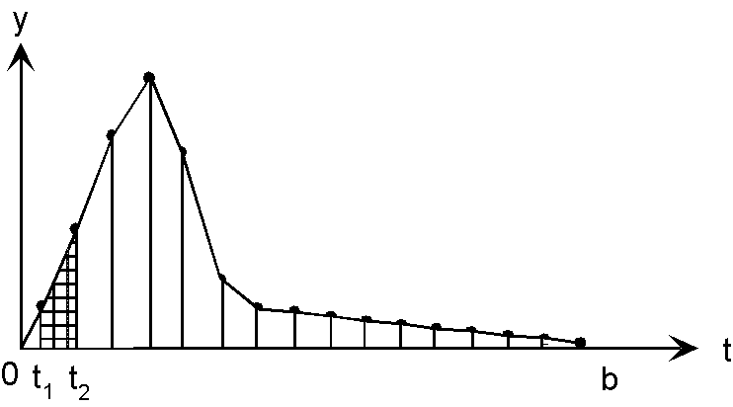
$$\frac{∆t}{2}({gyroSample}_{0}+ {gyroSample}_{1})$$
Figure 1-4
Figure 1-3

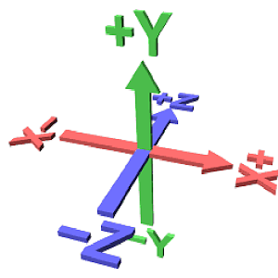
Accelerometer- An accelerometer measures the acceleration of the robot. This has many purposes. One of the main uses is to measure orientation relative to the ground. This works because since gravity is acceleration, the accelerometer reports this. By using some basic trigonometric functions, you can calculate how much of an angle there is between standard gravity and the acceleration on your appropriate axis. In Figure 1-6, the “Y+/-”axis would be perpendicular to the ground while the other two are parallel. As a result, that is the axis that would report the acceleration due to gravity. This can be used to calculate the angle of the robot according to either of the other axis using the equation in Figure 1-7. Considering our goal to add new autonomous functions to our programming to make us stand out, we looked at the accelerometer from a different perspective.
Figure 1-6
Figure 1-5
$$Atan(\frac{desiredOrientationAxis}{Y})$$
Figure 1-7

We decided to challenge ourselves with the task of calculating distance using only the accelerometer. This is theoretically possible due to the fact that acceleration is the second derivative of displacement so getting displacement from acceleration is a simple matter of double integrating your acceleration values to get displacement. This does not quite work so well in a practical environment however as with the gyro, a similar error begins to build up in the accelerometer. One reason for this is that we cannot guarantee a constant acceleration and our sampling rate is limited by hardware capabilities. Ideally, you would have to get the instant acceleration for infinite points in time to accurately calculate displacement when acceleration is non-constant. Since this is impossible, we have to assume a constant acceleration between samples. Since this is not actually the case, we begin to accumulate error which just keeps increasing. We decided again to use trapezoidal integration for this task. It is very similar to the one used for the gyro with the exception that it is performed twice now. We mostly succeeded in gathering our displacement from acceleration with the exception of it not being as accurate as would be practical for competition. Our average error margin was +-4 inches. Since our encoder-based move function is more accurate, we will use that for competition and continue work on this on the side in hopes to eventually have it competition worthy. Some of our recorded test data is in Appendix A.

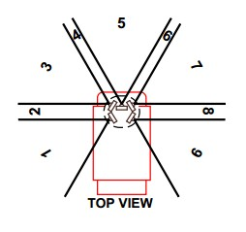
IR-The IR sensor senses infrared light of a certain frequency. It is actually composed of 4 separate IR sensors which are encapsulated within it. These provide the intensity of the signal that they find and the overall sensor calculates that and determines the “region” that the signal is coming from. There are thin regions and wider regions (as shown in Figure 1-8) and we try to use the thinner ones to increase accuracy. One thing that we found this year in particular is that from no place on the ramp could you determine a unique IR region for each of the three possible IR beacon positions. Anywhere we checked on the ramp, we received the same region for two positions of the beacon and then a unique region for the third. What we discovered though is that the top of the ramp provided a different overlap than the bottom allowing us to isolate the IR beacons position by taking the value twice, once at the top of the ramp and once at the bottom, and overlaying these to get three unique two-region identifiers.
Figure 1-8

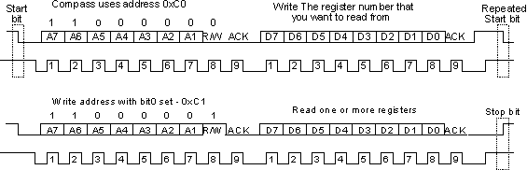
With these sensor improvements in progress, we are also trying to open up more room and potential for others by incorporating a prototype board. We are currently experimenting with a 3rd party 10-dof IMU named the GY-80. The key components of it are a three-axis accelerometer as well as a three-axis gyro. The only issue with these so far is that the IMU uses I2C to communicate with its master and the prototype board does not natively support acting as a master. This means that a software master must be coded to bit bang the sensor. One advantage of this is that when complete, we will be able to add up to 128 sensors per 2 digital pins on the prototype board. Figure 1-9 shows how I2C protocol works.
Figure 1-9

Our last major development we are working on so far is a program we are creating that allows for non-programmers to quickly and easily create autonomy for the robot. It is in its early stages and isn’t extremely capable yet, but the concept is there and has a foundation. It currently generates a list of commands in a list on its side which give accurate movement values based on lines the user draws on a scale-representation of the field. It converts the pixels covered by a line to inches and calculates the angles between any two consecutive lines that are drawn. The generated image showing routes can then be saved as a png file. We plan to make this more dynamic so that it can be used with any game and will actually generate the complete C file for you.
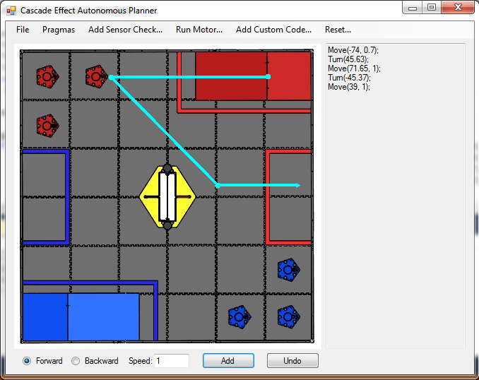
Figure 1-10 is a screenshot of the current state of the graphical autonomous designer we are designing. It currently works well enough to use the picture generated and to copy and paste the commands into an autonomy program.
Figure 1-10
STRATEGY
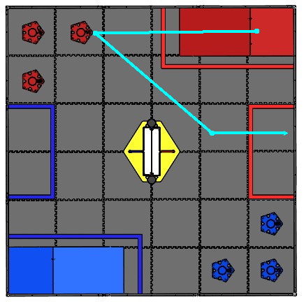
Our main autonomous strategy is to drive off of the ramp, collect a tube, drop a preload into the tube, and then carry the tube the remaining way to the parking zone.

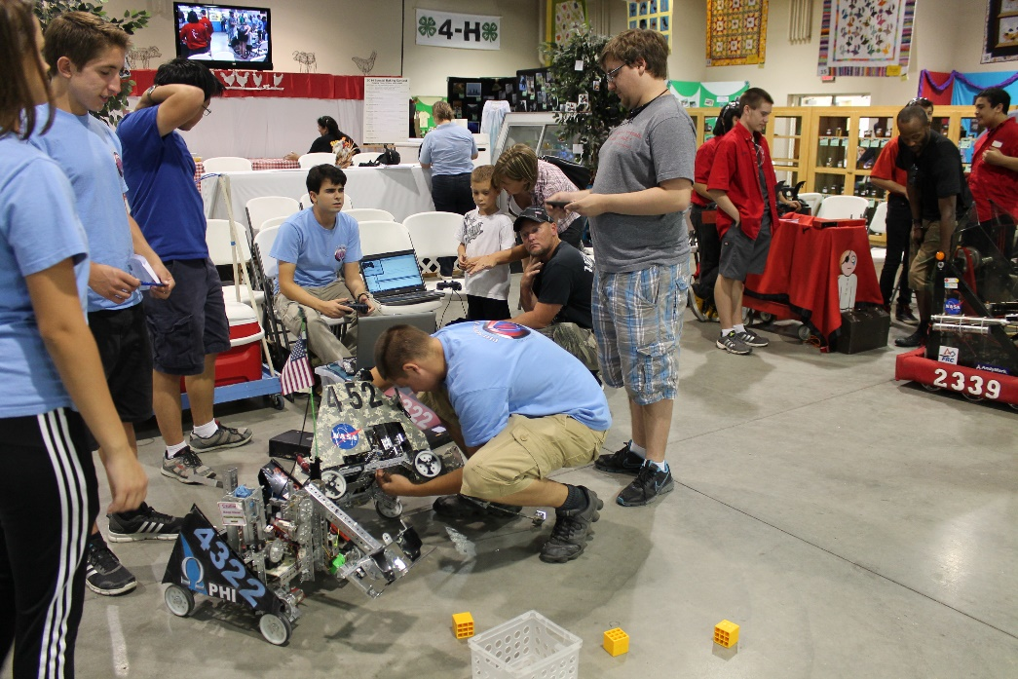
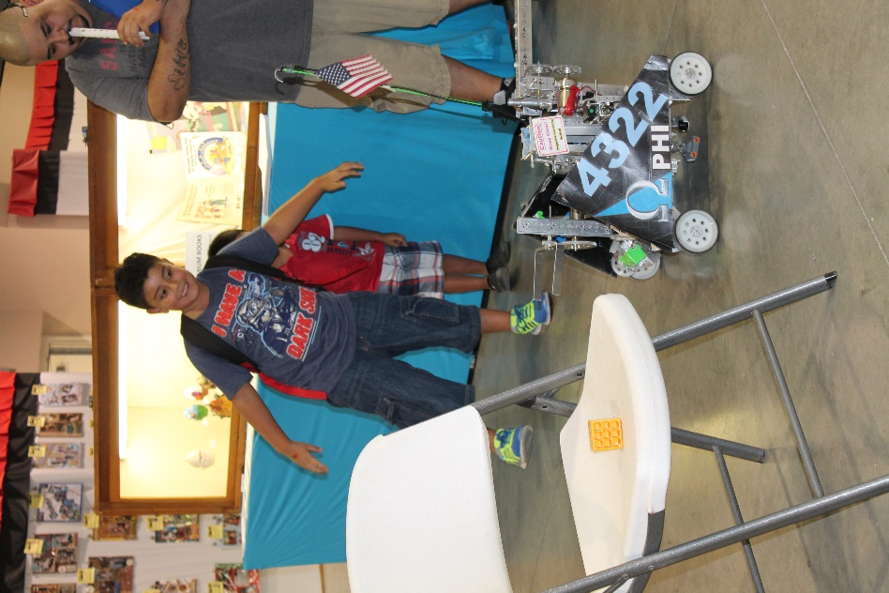
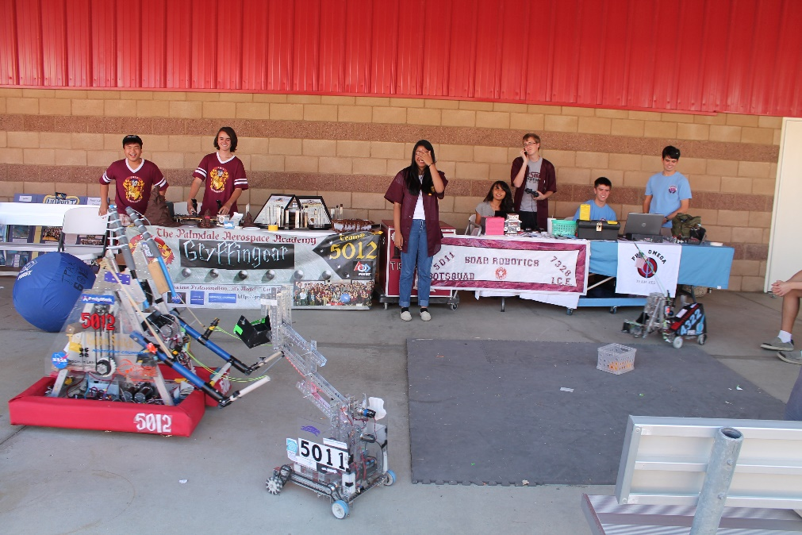
PHI Robotics, a 501(c)(3) nonprofit organization, is the greater umbrella over both our team and our sister team PHI Alpha. Since we operate as one team, we share sponsors, funds, and a budget.

FUNDRAISING

PHI is sponsored by corporations, private individuals, and our own fundraising events. Our corporate sponsors are Lockheed Martin, NASA, and Northrop Grumman. Lockheed Martin has generously given us funds, and NASA buys us parts and machines custom parts for us. Northrop Grumman also gives us funds. Our fundraising events have included everything from demonstrating our robots at restaurant events, selling Yankee candles, and hosting garage sales.
We seek to use our money wisely, which includes using it to help other teams. We fund two local FIRST LEGO League teams, and help fund another FTC team. In previous years we have also used our funds to host qualifying tournaments for the LA region.




